May 6, 2025
Mr. Wesley Dismore
City and County of Denver
Department of Transportation and Infrastructure
201 W. Colfax Avenue, Dept. 506
Denver, CO 80202

RE: Santa Fe Streetscape Design Services – Sub-consultant Add Letter
Dear Mr. Dismore,
Kimley-Horn and Associates, Inc. (“Kimley-Horn”) is formally requesting to add NG Companies to the Santa Fe Streetscape Design Project (“the Project”) for services related to the relocation and re-design of the existing storm line between 9th and 13th Avenue along Santa Fe Drive. NG Companies will be added to Task Order (PO-00137729) dated, September 13, 2023. NG Companies billing rates and classification are shown below and their specific scope of services are outlined in the change order request dated February 28, 2025.
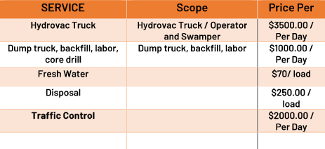
The number of days required per unit are outlined in the proposed fee estimate, Exhibit ‘A’ within the change order request dated, February 28, 2025. NG Companies is a critical piece of the Kimley-Horn team and are required to successfully deliver the project.
Sincerely,
KIMLEY-HORN AND ASSOCIATES, INC.
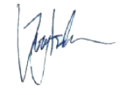
By: Jeremy Kahn, P.E.
Project Manager

